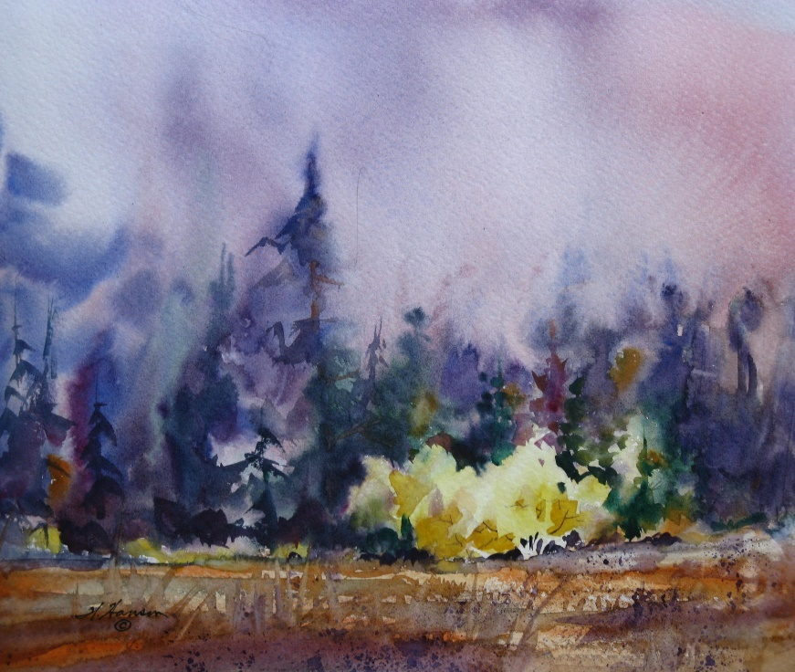**Wes Hanson Workshop**

Wes has painted for thirty-five years and displays his works at the Harrison Gallery in Harrison, Idaho. He has had many one-person exhibits in Spokane and Coeur d’Alene. He teaches art classes for North Idaho College, Spokane Art Supply, and the Artisan Barn in Uniontown, Washington. To see if there is space available in this class, call Wes at 208-667-9389. Leave your name and phone number.

**Painting Small Works**

Learn how to draw and paint small scenes in watercolor. Small paintings make great cards and gifts.

Saturday, November 19, 2016 from 10 till 4 (one-hour lunch break) at Spokane Art Supply (509-327-6628), 1303 N. Monroe, Spokane. Cost: $40 (US). Registration deadline: Monday, November 14.

**SUPPLY LIST**

Reference Materials: Photographs of subjects that hold special interest.

Drawing Materials: A No. 2 school pencil and inexpensive 8.5 by 11 inch paper.

Painting Materials: Painting Materials: One sheet (22 by 30 inch) of Arches 140 lb. all cotton cold press watercolor paper. A one inch flat and number 8 or 10 round watercolor brush. A basic watercolor paint set (student or professional grade) that has a white palette. A smooth 13 by 17-inch piece of plywood. A wide-mouth quart water container. One-inch wide masking tape. Paper towels.

-----------------------------------------------------------------------------------------------------------------------------------------

**To register, send this filled out and signed form and your check, payable to Wes Hanson, to Wes Hanson, 2725 W. Carder Ln., Coeur d’Alene, ID 83814.**

Your Name _____________________________ The Class Name ________________________________

Your Address __________________________________________________________________________

Your Phone Number ____________________________ Your Email __________________________________

Class size is limited. A waiting list will be used. All students are required to fill out and sign this registration form. This is an adult class, with teens accepted on pre-approval by the instructor. Signing this form will release Wes Hanson, Spokane Art Supply and associates of all responsibility for damages or harm incurred on the premises. After the registration deadline of November 14, there will be no refunds for students unable to attend the workshop.

Your Signature __________________________________________________ Date __________________________