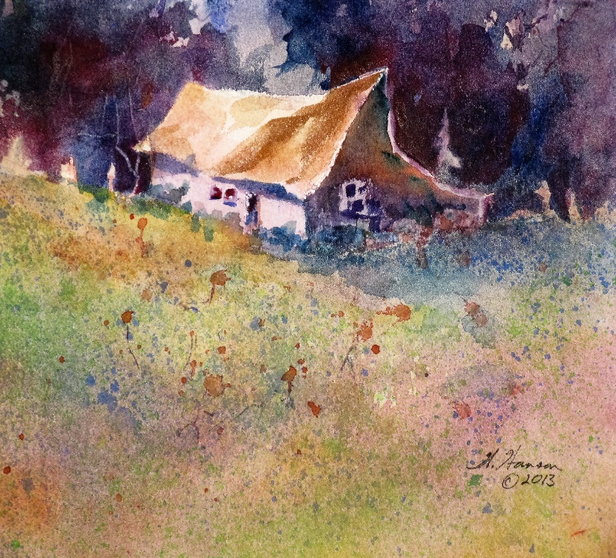**Wes Hanson Workshop**

Wes has painted for thirty-five years and displays his works at the Harrison Gallery in Harrison, Idaho. He has had many one-person exhibits in Spokane and Coeur d’Alene. He teaches art classes for North Idaho College, Spokane Art Supply and the Artisan Barn in Uniontown, Washington. To see if there is space available in this class, call Wes at 208-667-9389. Leave your name and phone number.

**Painting What You See and Imagine**

Learn how to accurately draw and paint centers of interest and create imaginative and energized landscapes around them.

Saturday, October 22, 2016 from 10 till 4 (One-hour lunch break) at Spokane Art Supply (509-327-6628), 1303 N. Monroe, Spokane. Cost $40 (US). Registration deadline: Monday, October 17.

**SUPPLY LIST:** Reference Material: Photographs of buildings in country landscapes.

Drawing Materials: A soft water soluble pencil. A black, permanent ink pen. A spiral bound sketchbook (approximately 9 by 11 inches) that can handle a light wash.

Painting Materials: One sheet (22 by 30 inches) of 140 lb. all cotton cold press watercolor paper, a one-inch flat and a number 8 or 10 round watercolor brush. Professional grade, mostly transparent, tube watercolor paints of the following colors or their equivalents: 1. Hansa or Azo Yellow, 2. New Gamboge, 3. Scarlet Pyrrol or Vermilion, 4. Quinacridone Rose or Permanent Alizarin Crimson, 5. Ultramarine Blue, 6. Thalo Blue, and 7. Burnt Sienna. A white plastic palette with ample mixing area. A smooth 13 by 17-inch piece of plywood. A wide-mouth quart water container. One-inch wide masking tape.

--------------------------------------------------------------------------------------------------------------------------------------------------------**To resister, send in this filled out and signed form and your check, payable to Wes Hanson, to Wes Hanson, 2725 W. Carder Ln., Coeur d’Alene, ID 83814.**

Your Name ______________________________________ The Class Name ________________________

Your Address __________________________________________________________________________

Your Phone Number _________________________________ Your Email __________________________

Class size is limited. A waiting list will be used. All students are required to fill out and sign this registration form. This is an adult class, with teens accepted on pre-approval by the instructor. Signing this form will release Wes Hanson, Spokane Art Supply and associates of all responsibility for damages or harm incurred on the premises. After the registration deadline of October 17, there will be no refunds for students unable to attend the workshop.

Your Signature___________________________________________ Date__________________________________