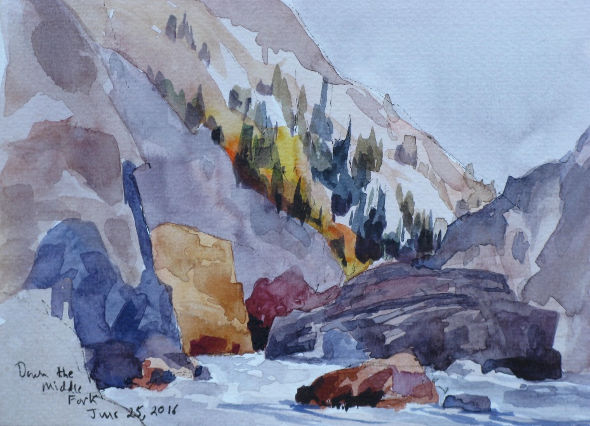**Wes Hanson Workshop**

Wes has painted for thirty-five years and displays his works at the Harrison Gallery in Harrison, Idaho. He has had many one-person exhibits in Spokane and Coeur d’Alene. He teaches art classes for North Idaho College, Spokane Art Supply, and the Artisan Barn in Uniontown, Washington. To see if there is space available in this class, call Wes at 208-667-9389. Leave your name and phone number.

**Sketching in Watercolor**

Learn how to simplify, draw and paint complex subjects in watercolor through demonstrations, guided instruction, and practice.

Saturday, September 24, 2016 from 10 till 4 (one-hour lunch break) at Spokane Art Supply (509-327-6628), 1303 N. Monroe, Spokane. Cost: $40 (US). Registration deadline: Monday, September 19.

**SUPPLY LIST**

Reference Materials: Photographs of subjects that hold special interest.

Drawing Materials: A soft, water soluble pencil and a waterproof black ink pen.

Painting Materials: A spiral bound sketchbook that can handle a wash. I use either the 9 by 12 inch Aquabee Super Deluxe 808 Sketchbook or the 8.5 by 11 inch Pentalic Nature Sketchbook. A one inch flat and a number 8 or 10 round watercolor brush. A basic watercolor paint set (student or professional grade) that has a white palette. A wide-mouth quart water container. One-inch wide masking tape. Paper towels.

-----------------------------------------------------------------------------------------------------------------------------------------

**To register, send this filled out and signed form and your check, payable to Wes Hanson, to Wes Hanson, 2725 W. Carder Ln., Coeur d’Alene, ID 83814.**

Your Name _____________________________ The Class Name ________________________________

Your Address __________________________________________________________________________

Your Phone Number ____________________________ Your Email __________________________________

Class size is limited. A waiting list will be used. All students are required to fill out and sign this registration form. This is an adult class, with teens accepted on pre-approval by the instructor. Signing this form will release Wes Hanson, Spokane Art Supply and associates of all responsibility for damages or harm incurred on the premises. After the registration deadline of September 19, there will be no refunds for students unable to attend the workshop.

Your Signature __________________________________________________ Date __________________________