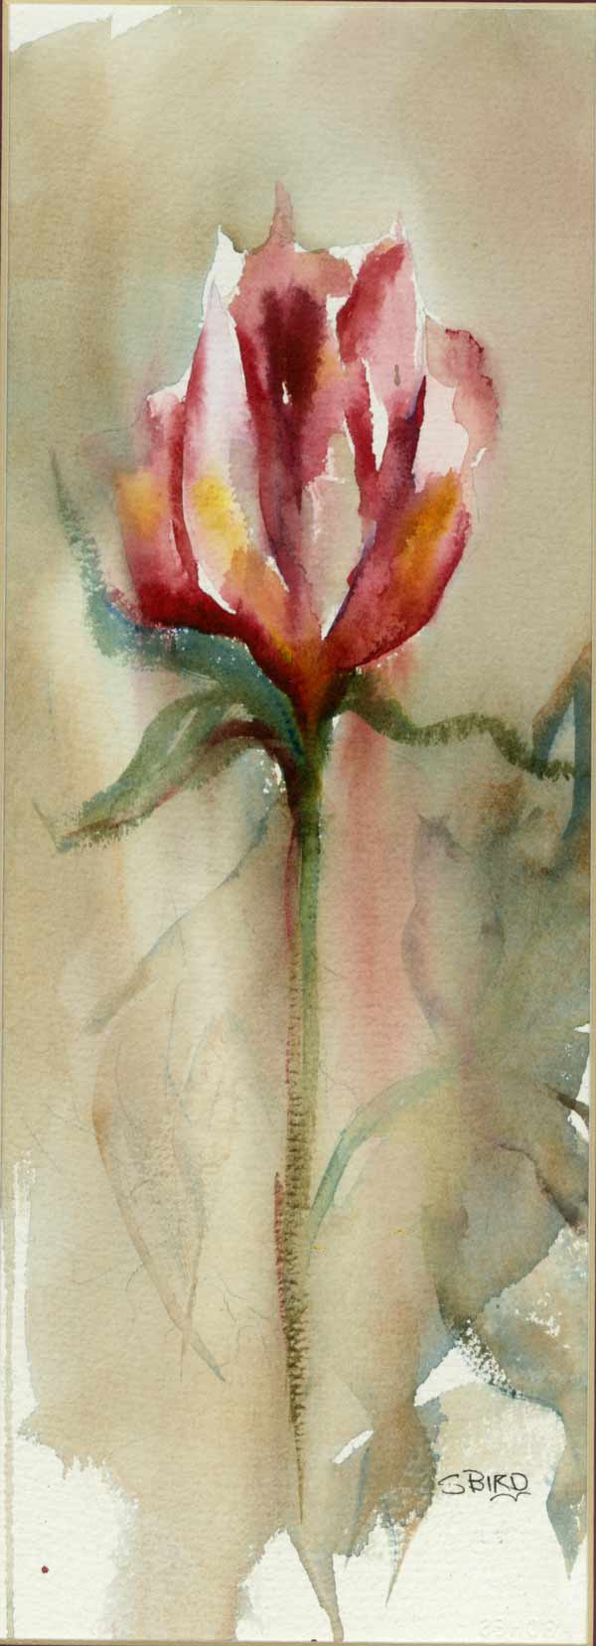

Basics and Beyond
Watercolor Class
Instructor Shirley Bird Wright
Morning 9 am to 12 noon
Fee: $12.00 each Monday
Evening 5:30 pm to 8pm
Fee: $12.00 each Monday
At Spokane Art Supply N. 1303 Monroe St.
for more information call
Shirley 981 6811 or Spokane Art Supply 327.6622
On going Every Monday Just Drop in
a different technique or subject matter taught each Monday

- ideal for shy beginners and more advanced students
- Classes are part demo and a lot of hands on painting
- we learn many watercolor techniques
- explore the magic of watercolor
Bring your paints brushes and paper – any supplies you have
Beginner Supply List will be discussed at first class I have supplies you can use for the first class.

About the teacher:
Shirley Bird Wright holds an Associate in Applied Science Degree in Visual Media Design Technology from Spokane Falls Community College.
For the past 30 years she has attended a variety of workshops to expand her understanding of art and to continue growing in new ideas, which she continually shares with others.
Bird possesses a natural talent and has a sensitive nature, which evidences itself in the subjects and style of her paintings.

