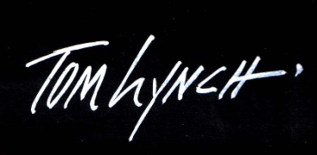

**Watercolor**

**Paintings & Prints**

[**www.tomlynch.com**](http://www.tomlynch.com)

***SALVAGE TECHNIQUES FOR DISCARDED PAINTINGS***

Sit back and let Tom show you how to … add a few finishing touches or … a complete makeover to randomly selected paintings*. You will come away from this demo seeing how a failed painting can be saved; a good painting can become great; and a great painting can become an award winner! Learn the five most common errors in painting and see how to correct them. Bring your camera to record the “before” and “after”. When this class is over you will never throw a painting away again!

***Welcome to the watercolor world of Tom Lynch …***

*and let him lead you on an exciting adventure into color, contrast and dramatic light.*

REV 1-17-04

**25111 W. Ramm Drive ● Suite #10 ● Naperville, IL 60564 ● TEL 630-851-2652 ● FAX 630-851-2588**

*Need about 12 – 14 completed paintings for Tom to choose from (that you do not mind Tom working on).

Paintings should be done on a ½ sheet or smaller and be available for Tom to view 1 hour prior to start of demo.

25W111 Ramm Drive Suite #10 ● Naperville, IL 60564 ● 630-851-2652 ● email Tomlynch @msn.com